Namespace
- Namespace is logical/virtual cluster within k8s cluster
- K8s resources will be of two categories by scope
Namespace resources: They belong to a namespace.
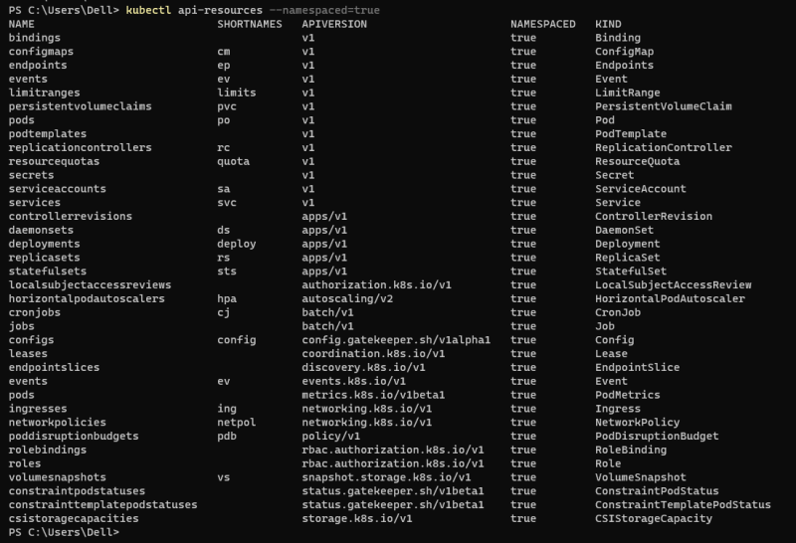
Cluster resources: They belong to a cluster
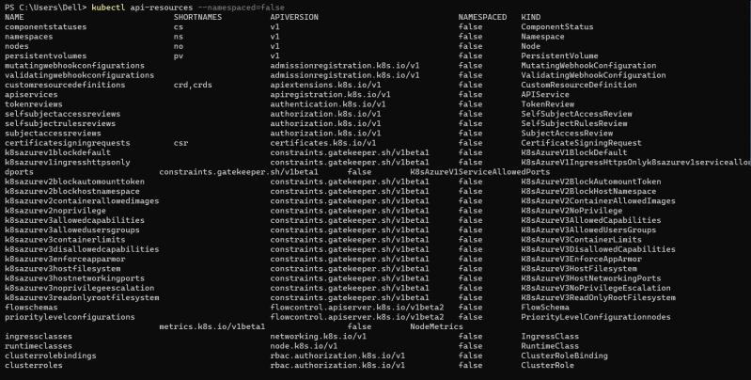
Creating namespace: kubctl create ns <name>
Namespace type

Config Map

When We create application, we need to pass multiple metadata or argument. We can define those as config map
- https://kubernetes.io/docs/concepts/configuration/configmap/ for official docs
- Let’s create a dummy config map.
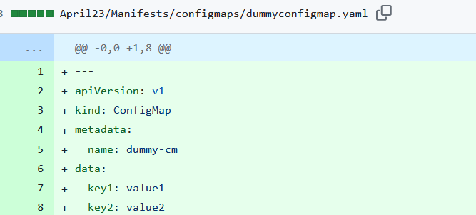
- Create the config map
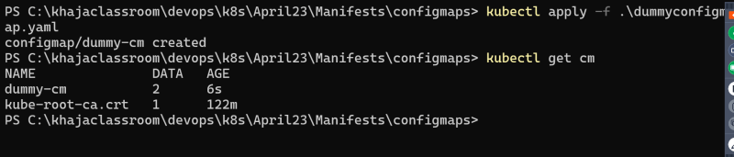
- Lets configure a pod to use this config map. https://kubernetes.io/docs/concepts/configuration/configmap/#configmaps-and-pods

- There are four different ways that you can use a ConfigMap to configure a container inside a Pod:
  - Inside a container command and args
  - Environment variables for a container
  - Add a file in read-only volume, for the application to read
  - Write code to run inside the Pod that uses the Kubernetes API to read a ConfigMap
- Load config map data as Environment variables.
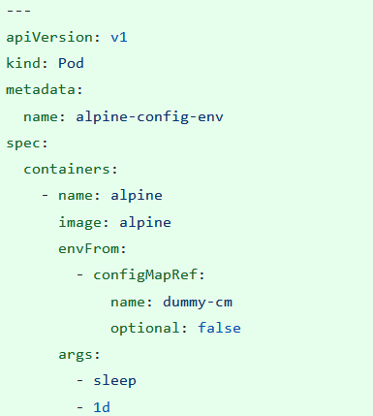
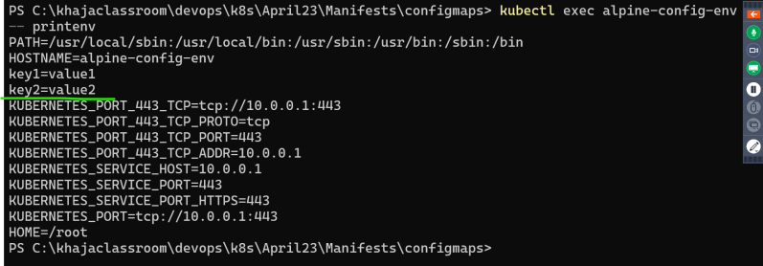

Secrets
- https://kubernetes.io/docs/concepts/configuration/secret/ for k8s secrets
- Secrets can be created from kubectl https://kubernetes.io/docs/tasks/configmap-secret/managing-secret-using-kubectl/#use-raw-data and manifest files https://kubernetes.io/docs/tasks/configmap-secret/managing-secret-using-config-file/#edit-secret
- Create a secret and describe secret
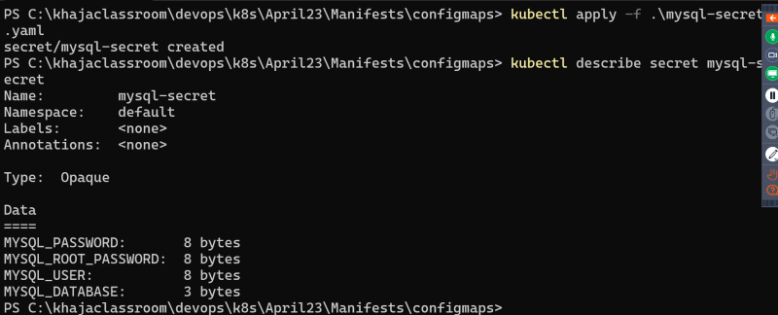
- use the secret in Pod as environment variable
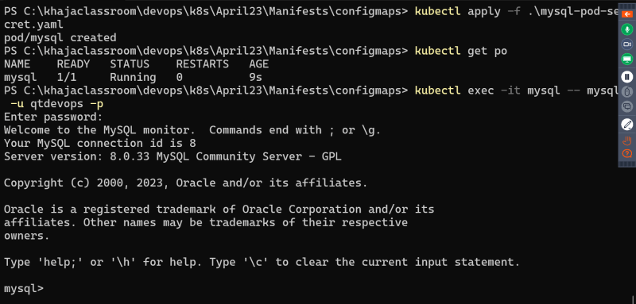

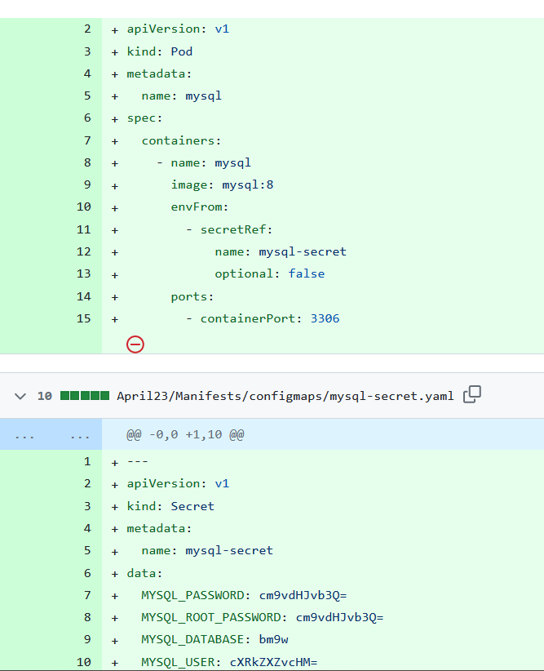

RBAC: Authorization in K8s Refer Here
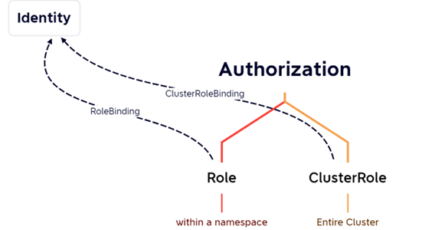
- Authentication in k8s https://kubernetes.io/docs/reference/access-authn-authz/authentication/
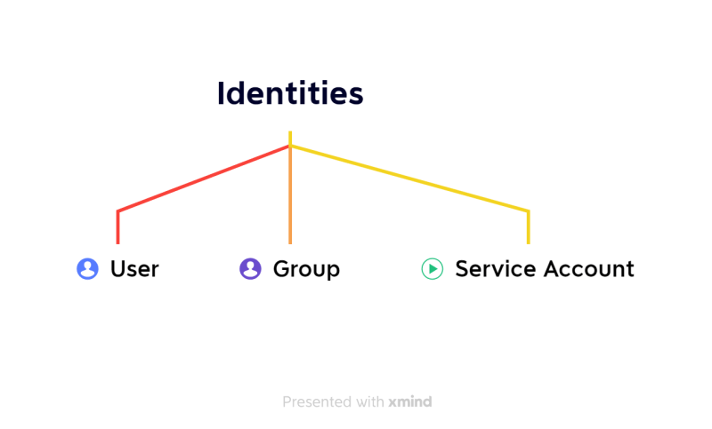
- Attaching Authorization to identity using Bindings
  - RoleBinding
  - ClusterRoleBinding
- https://www.adaltas.com/en/2019/08/07/users-rbac-kubernetes/ for creating users and setting permissions

